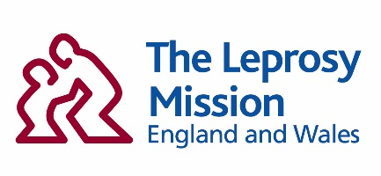

Volunteer Speaker

Role Outline

- MAIN PURPOSE OF ROLE
To present the work of The Leprosy Mission to church and secular groups using suitable visual aids and to encourage them to respond to the presentation both prayerfully and financially.

- ROLE POSITION IN ORGANISATION
- Reporting to the Community Partnerships Manager

- MAIN ACTIVITIES
- To make bookings for talks through personal contacts and accept those made by the Community Partnerships Manager
- To deliver compelling talks, sermons and updates using PowerPoint and video content in person and on Zoom
- To encourage a financial response to the presentation/sermon with the help of the supplied materials, such as envelopes and Direct Debit forms
- To inspire prayer for the work of TLM through the promotion of ASK (the TLM annual prayer diary), the quarterly prayer bulletin and becoming a prayer ambassador
- To bank donations and email the Supporter Relations Team so that the database is updated accordingly

- QUALIFICATIONS & SKILLS LEVEL
- A clear audible voice
- Fluent English speaker
- Valid UK driving licence
- Confident Microsoft Office and Zoom user

- PROVEN ABILITY
- Experience in public speaking is essential
- Experience of preaching is desirable

- SAFEGUARDING STATEMENT AND HOW IT APPLIES TO THIS ROLE

TLMEW has a zero-tolerance policy towards any abuse, neglect, and exploitation to all people. Safeguarding is everyone's responsibility, and all volunbteers are required to act in such a way that always safeguards the health and wellbeing of children and vulnerable adults. The role holder must sign, be familiar with, and comply with all TLMEW organisational policies, including the TLMEW Code of Conduct, Safeguarding Children & Vulnerable Adults Policy and the TLMEW Safeguarding Children & Vulnerable Adults Procedures. All TLMEW volunteers are required to participate in mandatory safeguarding training.

Safeguarding Risk Level: High

This role has been assessed as having a ‘high’ level of safeguarding risk. This is because the role potentially involves being alone, or having physical contact, with a child or vulnerable adult. Alternatively, the role may have control over the provision of goods or services; or provide safeguarding advice; or promote safeguarding awareness.

TLMEW will put relevant mitigation measures in place in order to lower the level of safeguarding risk. For example, these will include: enhanced recruitment procedures, support from staff with safeguarding expertise, and six-monthly assessment of role-related safeguarding risks. It is expected that the role holder will collaborate so that these measures can be put in place.

