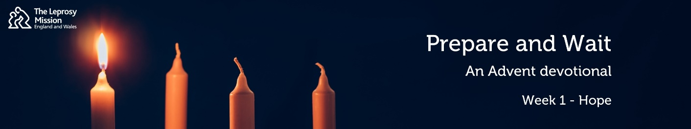
Prepare & Wait: an Advent Devotional from the Leprosy Mission
1: Hope
Hello! My name is Chris and welcome to this Advent Devotional. Advent is a time of preparation. There is a lot to think about in the run up to Christmas: cards to send, presents to buy, the house to decorate, food to prepare and more. Advent is also a time of waiting for Christmas Day. This year it is difficult to make plans, as we wait not knowing whether we will be able to visit relatives or celebrate in ways we normally would. For Christians, Advent is a reminder that just as the patriarchs and prophets prepared the way for Jesus’ coming into the world and waited patiently for him, we wait and prepare for Jesus to return. As followers of Jesus we can take courage and prepare our hearts this Advent. It is my prayer that as we journey together over the coming weeks, you will know and experience the hope, peace, joy and love that come from our God.
Our first reading is taken from Genesis 15:1-5.
15 The word of the Lord came to Abram in a vision: “Do not be afraid, Abram. I am your shield, your very great reward.” ² But Abram said, “Sovereign Lord, what can you give me since I remain childless and the one who will inherit my estate is Eliezer of Damascus?” ³ And Abram said, “You have given me no children; so a servant in my household will be my heir.” ⁴ Then the word of the Lord came to him: “This man will not be your heir, but a son who is your own flesh and blood will be your heir.” ⁵ He took him outside and said, “Look up at the sky and count the stars—if indeed you can count them.” Then he said to him, “So shall your offspring be.”
Our second reading is taken from Romans 4:18-21.
¹⁸ Against all hope, Abraham in hope believed and so became the father of many nations, just as it had been said to him, “So shall your offspring be.” ¹⁹ Without weakening in his faith, he faced the fact that his body was as good as dead—since he was about a hundred years old—and that Sarah’s womb was also dead. ²⁰ Yet he did not waver through unbelief regarding the promise of God, but was strengthened in his faith and gave glory to God, ²¹ being fully persuaded that God had power to do what he had promised.
When we use the word ‘hope’, it can sometimes feel like the outcome we are looking for is unlikely to pan out. We might look out at dark grey clouds and say “I hope it doesn’t rain”. I have Italian ancestry and as a result, I like to support Italy in the 6 Nations rugby. When I say “I hope Italy wins the match today”, it’s difficult to have genuine confidence in the result that I would like! Hope can feel like something faint and weak, something we only have a glimmer of. But the way the Bible understands hope is very different. Instead, hope is a confident expectation of what is to come.
For Abraham, at the age of a hundred it must have seemed impossible that he and Sarah would have a son. But against all odds, he was fully persuaded that God had the power to do what he had promised. Through Abraham’s line, a Saviour would be born through whom all nations would find blessing. The tiny baby, Immanuel, was God with us. He would live, die and be raised, so that we could have the full assurance of hope of eternity with God. What a great hope!
Meera is six years old and lives in India with her parents and three siblings. She is an active, bubbly and cheerful girl who puts a smile on the faces of everyone around her. Around 18 months ago, her family noticed pale patches of skin on Meera’s face and body, where she had begun to lose feeling. The family did not worry about this at first, but as Meera’s condition got worse, they brought her to The Leprosy Mission’s Purulia Hospital where Meera was diagnosed with leprosy. Because of you, she was given the cure for leprosy and she has been given physiotherapy for her weak fingers. Wonderfully, the doctors are confident that her hands will improve completely. Meera can have real hope for the future, free from the damage or discrimination that leprosy can cause, as she returns to school after lockdown. Thank you for bringing healing to Meera and many others just like her.
In these challenging times this Advent, let us place our confidence in the God of all hope, who has the power to do all that he has promised.

