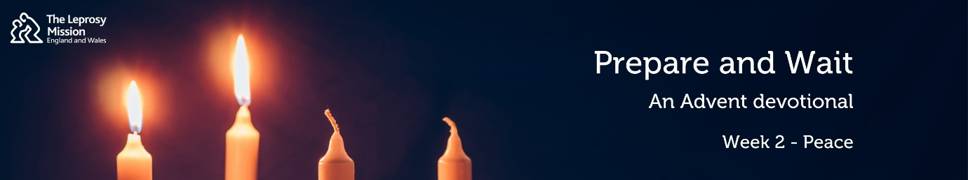
Prepare & Wait: an Advent Devotional from the Leprosy Mission
2: Peace
Hello and welcome to Prepare and Wait, an Advent devotional. As we make arrangements for Christmas, we remember that the prophets prepared the way for Jesus’ coming into the world and waited for him. We can take heart at Advent as we wait and prepare for Jesus’ return. My name is Chris and it is my prayer that you will know and experience God’s hope, peace, joy and love afresh this Advent. This week we are reflecting on peace.
Our first reading is taken from Isaiah 9:6-7:
⁶ For to us a child is born, to us a son is given, and the government will be on his shoulders.
And he will be called Wonderful Counselor, Mighty God, Everlasting Father, Prince of Peace.
⁷ Of the greatness of his government and peace there will be no end. He will reign on David’s throne and over his kingdom, establishing and upholding it with justice and righteousness from that time on and forever. The zeal of the Lord Almighty will accomplish this.
Our second reading is taken from John 14:27-29:
²⁷ Peace I leave with you; my peace I give you. I do not give to you as the world gives. Do not let your hearts be troubled and do not be afraid. ²⁸ “You heard me say, ‘I am going away and I am coming back to you.’ If you loved me, you would be glad that I am going to the Father, for the Father is greater than I. ²⁹ I have told you now before it happens, so that when it does happen you will believe.
You may have heard a story about an art competition promoted by a man looking for a picture that encapsulated ‘peace’. One artist painted a lake with crystal clear water and a cloudless sky. Another painted lush, emerald fields with a beautiful sunset on the horizon. When the winner was announced, the competitors were astonished. The winning painting looked anything but peaceful. The scene showed a thundery sky with a waterfall crashing down a cliff into the raging waters below. But as the competitors looked at the painting more closely, they realised that in a cleft of the rock was a bird sitting serenely on its nest of young. This image is captured in Jack E. Dawson’s painting, ‘Peace in the Midst of the Storm’. You see, peace is not the absence of a storm, but rest in the middle of the storm.
In the carol ‘Silent Night’ we sing “all is calm…sleep in heavenly peace” about the scene of Mary and Joseph with the newborn Jesus. A filthy stable full of noisy animals might not seem the best place to find peace. But the Hebrew word for peace, ‘shalom’, is more complex than just tranquillity; it also means wholeness. Isaiah had prophesied that the coming Messiah would be called Prince of Peace and that by his wounds, we would be healed. The Messiah’s body would be broken as he was nailed to a cross and his side pierced, in order to mend the brokenness of humanity and make us whole, to give us peace with God.
Jesus knew that his disciples would face storms in life, including violent persecution. He needed to tell them that he was giving them his peace, so they did not need to fear. His peace was greater than any peace the world could offer. Jesus, the Lord of the Sabbath, will give ultimate rest to his people when he returns. In the meantime, and through our restlessness, we can know his peace as we look ahead to his coming.
Shanmugam lives in Sri Lanka with his family. Sadly, he has a disability caused by his leprosy and as a result, he was no longer able to support his family and was struggling for income. His family did not even have any access to drinking water at home. But at Shanmugam’s point of brokenness, you have brought wholeness. Thanks to you, the Leprosy Mission and our partners were able to provide a tube well and help Shanmugam to start a home garden, brimming with fruit trees and fresh vegetables. Shanmugam is able to sell his produce to provide an income and is so grateful that because of you, his family has not needed to live in fear of not having enough food during the pandemic. Thank you for bringing peace to Shanmugam.
Whatever you face this Advent, know that the wholeness that Jesus offers gives you rest through the storm.

