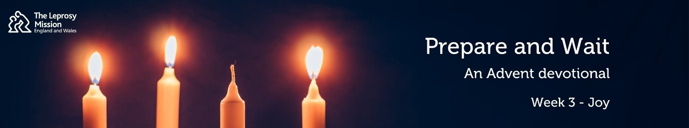

Prepare & Wait: an Advent Devotional from the Leprosy Mission

3: Joy

Readings: Luke 1:8-17; Luke 3:2-6

Hello, my name is Jarrett. I am a volunteer speaker for The Leprosy Mission and it is my privilege to contribute to this year’s Advent devotionals. This week’s theme is Joy. For those of you joining us for the first time, this is week 3, and we are looking at Luke Chapter 1, verses 8-17, and Chapter 3, verses 2-6.
⁸ Now while [Zechariah] was serving as priest before God when his division was on duty, ⁹ according to the custom of the priesthood, he was chosen by lot to enter the temple of the Lord and burn incense.¹⁰ And the whole multitude of the people were praying outside at the hour of incense. ¹¹ And there appeared to him an angel of the Lord standing on the right side of the altar of incense. ¹² And Zechariah was troubled when he saw him, and fear fell upon him. ¹³ But the angel said to him, “Do not be afraid, Zechariah, for your prayer has been heard, and your wife Elizabeth will bear you a son, and you shall call his name John. ¹⁴ And you will have joy and gladness, and many will rejoice at his birth, ¹⁵ for he will be great before the Lord. And he must not drink wine or strong drink, and he will be filled with the Holy Spirit, even from his mother's womb. ¹⁶ And he will turn many of the children of Israel to the Lord their God, ¹⁷ and he will go before him in the spirit and power of Elijah, to turn the hearts of the fathers to the children, and the disobedient to the wisdom of the just, to make ready for the Lord a people prepared.”
³ And he went into all the region around the Jordan, proclaiming a baptism of repentance for the forgiveness of sins.⁴ As it is written in the book of the words of Isaiah the prophet,
“The voice of one crying in the wilderness:
‘Prepare the way of the Lord,^{[a]}
make his paths straight.
⁵ Every valley shall be filled,
and every mountain and hill shall be made low,
and the crooked shall become straight,
and the rough places shall become level ways,
⁶ and all flesh shall see the salvation of God.’”

When I was about 10 years old, I absolutely loved sport. I would play just about any kind of sport there was: football, tennis, basketball…if a ball was involved, I was keen to play. But although I loved playing sports, I was never looked at as being one of the better players. My PE class at primary school would regularly host competitions for all kinds of sports and athletics, and no matter how hard I tried I could never seem to win those competitions, nor even come close. But one day, when our entire year group was assembled in the gym, I was surprised to be presented with an award: our gym teachers had me come to front and told me, in front of everyone, how I was being rewarded for always putting in an effort and staying positive. They said I was an example to everyone – something I had never been told before. I walked out of that gym feeling ten feet tall. I remember feeling shocked, but full of joy.

Have you ever received truly joyful news when you least expected it?

In our readings from Luke, Zechariah receives news that was much more surprising and unexpected than the kind of news I received. An angel appears to him when he is in the temple, and proclaims to him good news: after decades of being unable to have children, Zechariah and his wife Elizabeth were to have a son. His reaction to the angel is probably similar to how any of us would have responded: in disbelief, he replies, ‘How can I be sure of this? I am an old man and my wife is well on in years.’

The context of this is interesting. The announcement of the birth of John the Baptist coincides with what might have been the pinnacle of Zechariah’s service as a priest. There were 18,000 such priests serving the people, and as such Zechariah would have found himself serving in the temple only twice a year. On this day, Zechariah is chosen by lot to burn incense on the Altar of Incense in the Holy Place. This was an honour considered so great that no priest was allowed to do it more than once in his life.

The inclusion of Elizabeth is also fascinating. Throughout the Hebrew Scriptures, on almost every occasion that we find a woman who cannot bear children, we come to find out that God has set her aside for something magnificent. Consider Abraham’s wife Sarah or Jacob’s wife Rachel in the book of Genesis, or Samson’s mother in the book of Judges, or Hannah in 1 Samuel. Luke is building us up to something significant. We are given line after line of coincidence, momentousness, and high improbability, uniting in one to create an extraordinary scene.

The once-in-a-lifetime priestly service, the burning of incense and eager anticipation in prayer, the appearance of an angel, the announcement of John’s birth to a woman who was heretofore unable to have children…Luke wants his readers to understand the incomparable joy of this scene, and for us to see clearly that with God, nothing is impossible.

Three years ago, I had the privilege of visiting Nigeria, where I was able to see the work of The Leprosy Mission in action. I met so many people living in challenging circumstances and many with heart-breaking stories of loss and rejection. But by far the word I heard the most from those I met was ‘na gode’ – which in Hausa means ‘thank you’. Everywhere I went, there was a story that started in despair but ended in thankfulness, and joy.

One of those I met was called Johanna. When he lost sensitivity in his foot and developed a recurring ulcer, his leg had to be amputated. But after being cured of his leprosy, he settled in a community near to The Leprosy Mission’s orthopaedic workshop. Most of us could imagine feeling discouraged to lose a leg; not Johanna. I never saw him without a beaming, joyful smile on his face. He told me how grateful he was that The Leprosy Mission and local churches would come to meet his needs. Most unexpectedly, here was a man who was living the joy of the Good News of the Gospel. This Advent, may you too get a personal sense of that joy, and in the most unexpected of ways, and may we all come to see the salvation of God.

