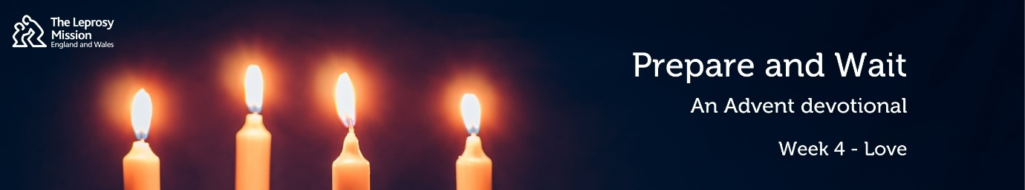
Prepare & Wait: an Advent Devotional from the Leprosy Mission
4: Love
Hello! My name is Kate and welcome to your last Advent Devotional in our Prepare and Wait series. Thank you for journeying with us through Advent, as we have considered the themes of hope, peace and joy. This week we are reflecting on love.
Our first reading is from Luke 1:26-33.
²⁶ In the sixth month of Elizabeth’s pregnancy, God sent the angel Gabriel to Nazareth, a town in Galilee, ²⁷ to a virgin pledged to be married to a man named Joseph, a descendant of David. The virgin’s name was Mary. ²⁸ The angel went to her and said, “Greetings, you who are highly favoured! The Lord is with you.” ²⁹ Mary was greatly troubled at his words and wondered what kind of greeting this might be. ³⁰ But the angel said to her, “Do not be afraid, Mary; you have found favour with God. ³¹ You will conceive and give birth to a son, and you are to call him Jesus. ³² He will be great and will be called the Son of the Most High. The Lord God will give him the throne of his father David, ³³ and he will reign over Jacob’s descendants forever; his kingdom will never end.”
Our second reading is from Ephesians 2:4-10.
⁴ But because of his great love for us, God, who is rich in mercy, ⁵ made us alive with Christ even when we were dead in transgressions—it is by grace you have been saved. ⁶ And God raised us up with Christ and seated us with him in the heavenly realms in Christ Jesus, ⁷ in order that in the coming ages he might show the incomparable riches of his grace, expressed in his kindness to us in Christ Jesus. ⁸ For it is by grace you have been saved, through faith—and this is not from yourselves, it is the gift of God— ⁹ not by works, so that no one can boast. ¹⁰ For we are God’s handiwork, created in Christ Jesus to do good works, which God prepared in advance for us to do.
The original language of the written New Testament was Greek. When Gabriel tells Mary that she has found ‘favour’ with God, that is the same word as ‘grace’ in our reading from Ephesians. This word, ‘charis’, describes God’s loving kindness that by its nature is undeserved. Grace can’t be earnt or bought. Paul explains that grace is not from ourselves; it’s a free gift from God. Luke doesn’t tell us that Mary was a wonderful person, always giving her time and energy to others. Instead, his focus is that Mary has been shown grace by God. Mary recognises this in her song of praise to God that follows in Luke’s gospel when she says, “He has looked on the humble state of his servant…He who is mighty has done great things for me”. Grace is all about what God has done, that in love he sent his Son Jesus to earth to become one of us, so that he could die in our place. Jesus rose again and reigns forever at God’s side, which assures us we will be seated in the heavenly realms with Jesus in a kingdom that will never end. All because of God’s grace, simply because he loves us. Christina Rossetti’s poem, published 135 years ago echoes this truth: “Love came down at Christmas, love incarnate, love divine”.
Shaimi is from rural Nepal and has two daughters. When Shaimi developed patches on her skin, her husband noticed it was leprosy and tragically left her. She was terrified and felt powerless to help her daughters and her parents who relied on her. In her desperation, she accepted a job in hospitality in Kuwait, having to leave her daughters behind. Shaimi had lost feeling in her hands and arms due to her leprosy, so it wasn’t long before she got burned on an open flame while cooking. She pleaded with her employer to let her do another job, but they told her it was this or nothing. When Shaimi had saved up enough money she travelled back to her family in Nepal. She broke down as she showed them her fingers that had become stiff and bent through nerve damage, and the scars on her arms. Her father explained that since she had been gone, he had been diagnosed with leprosy at Anandaban Hospital, a 17-hour journey from their village. Shaimi travelled to the hospital with her mother where she received the cure for leprosy and was taught physiotherapy exercises for her fingers. When the staff at Anandaban found out that Shaimi couldn’t afford for her two daughters to go to school, they arranged for the girls to receive scholarships to cover the cost of their uniforms and materials. Because of you, Shaimi was shown God’s loving kindness through the wonderful staff at Anandaban Hospital. At The Leprosy Mission, we are so grateful that a gift of just £24 brings the cure for leprosy to someone just like Shaimi this Christmas.
May you know the incomparable riches of God’s grace, expressed in his kindness to you in Jesus. Along with everyone at The Leprosy Mission, I wish you a peaceful Christmas and a joy-filled New Year.

